COOK BOOK: YOUR VIRTUAL KITCHEN ASSISTANT

**TEAM DETAILS:**

|  |  |  |
| --- | --- | --- |
| **TEAM LEADER** | BINDU M | bindugehlothm@gmail.com |

**TEAM MEMBERS:**

|  |  |  |
| --- | --- | --- |
| **MEMBER 1:** | BINDU M | Coding and Demo Video |
| **MEMBER 2:** | ARIYALAKSHMI B | Manage team members |
| **MEMBER 3:** | ASHWINI KIRUBHA A | Documentation (minor part) |
| **MEMBER 4:** | FAAHIMA M | Documentation (major part) |
| **MEMBER 5:** | HARSHA K | Executing code and explain to the team |

**INTRODUCTION:**

COOK BOOK: YOUR VIRTUAL KITCHEN ASSISTANT is a smart user friendly mobile application designed to simplify and enhance your cooking experience whether you are a home chef or just getting started in the kitchen , COOK BOOK helps to you to discover , organise and prepare meals with confidence and ease .

The app serves as you’re all – in – one digital kitchen companion , offering features such as personalised recipes , recommendations , step by step cooking guidance , grocery list management , and meal planning tools. With an intuitive interface and intelligent features, Cookbook adapts to your preferences, dietary needs, and cooking habits to make every meal a success.

Cookbook transforms the way users approach cooking —from planning and shopping to prepping and plating—turning everyday cooking into an effortless and enjoyable experience.

**PROJECT OVERVIEW:**

**PURPOSE :**

The primary goal of CookBook is to provide a user-friendly platform that caters to individuals passionate about cooking , baking , and exploring new culinary horizons .Our objectives include:

* USER-FRIENDLY EXPERIENCE: Create an interface interface that is easy to navigate, ensuring users  can effortlessly discover, save, and share their favourite recipes.
* COMPREHENSIVE RECIPE MANAGEMENT: Offer robust features for organizing and  managing recipes, including advanced search options.
* TECHNOLOGY STACK: Leverage modern web development technologies, including  React.js, to ensure an efficient, and enjoyable user experience.

**KEY FEATURES:**

* The app helps users find recipes suitable for various occasions, likely sorted by meal types, cuisines, or dietary preferences.
* The homepage prominently features high-quality images of dishes.
* This visual-first approach makes it easy to browse and get inspired by the appearance of the meals.
* A search bar is visible in the top right corner with a placeholder: “Type something…” and a “Search” button. This allows users to quickly find specific recipes or ingredients.
* A button labelled & “Recipes” encourages users to dive deeper into the app’s recipe library.

**ARCHITECTURE:**

**COMPONENT STRUCTURE:**

* App component: Root component
* Header components: Logo (e.g., “AMV Recipes”) and Navigation.
* Sidebar components: Filter categories (e.g., cuisine , difficulty , dietary type)
* Footer components: Links About , Contact , Terms , etc.

**STATE MANAGEMENT:**

Currently manages using React’s built-in useState and props.

**ROUTING:**

Using React Routing Configuration defines how different components or pages are mapped to specific URL paths.

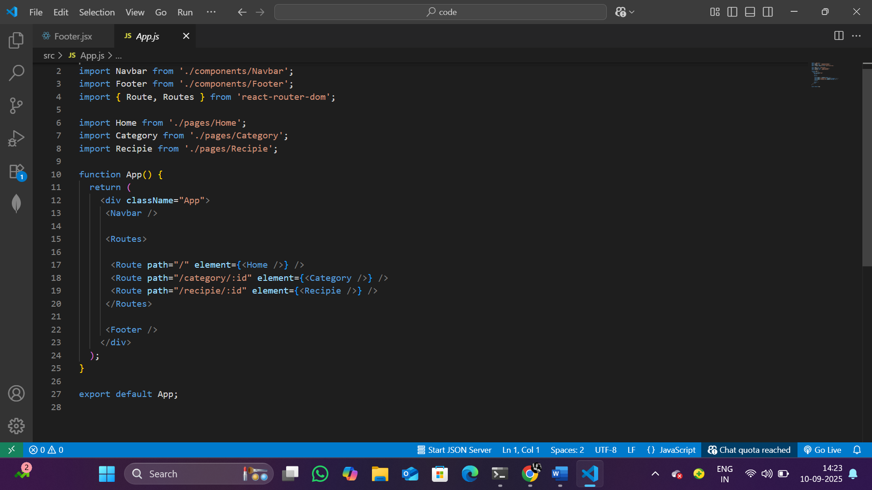

IMG 1: ROUTING

**SETUP INSTRUCTION:**

PRE REQUISITES:

* Node.js and npm
* React.js
* HTML , CSS amd javascript
* VS-Code
* Git/Github

INSTALLATION:

* Node.js: Install node.js and npm on your development machine , as they are required to run javascript on the server-side. Download : <https://nodejs.org/en/download/> . After downloading , the installation process begins .
* IN WINDOWS:

Run the download .msi installer.

Follow the setup wizard:

* Accept the license agreement.
* Choose the destination folder.
* Make sure “Add to PATH” is selected.
* Keep default options unless you know otherwise.
* Finish the installation.

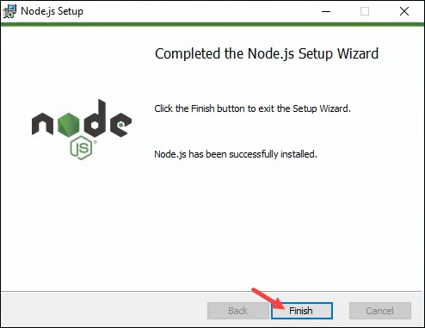

IMG 2: NODE INSTALLATION

VERIFY THE INSTALLATION:

* Open the Command Prompt or Powershell . Enter to check the Node.js version.
* Type npm –v and press enter to check the npm version.
* Both commands should return version numbers , confirming successful installation.
* React.js: Create a new React app:
* npx create-react-app my-react-app
* Replace my-react-app with your preferred project name
* Navigate to the project directory .

cd my-react-app

* Running the React app : With the react app created , you can now start the development server and see your react application action.
* Start the development server:

npm start

This command launches the development server, and you can access React app at <https://localhost:3000> in your web browser.

**FOLDER STRUCTURE:**

CLIENT:

* Src/components – Reusable components.
* Src/pages – individual page layouts.
* Src/assets – images , styles.
* Src/app.js – root application.

UTILITIES:

The helper functions likely focus on handling API interactions , data formatting , error handling , and local storage.

**RUNNING THE APPLICATION :**

* Open the VS-Code and you can see the code file in it.
* You have to install node modules for the project execution , So use this command: npm install
* After installing all the node modules enter the project run command: npm start
* Now your application will be opened in browser with URL: <https://localhost:3000>

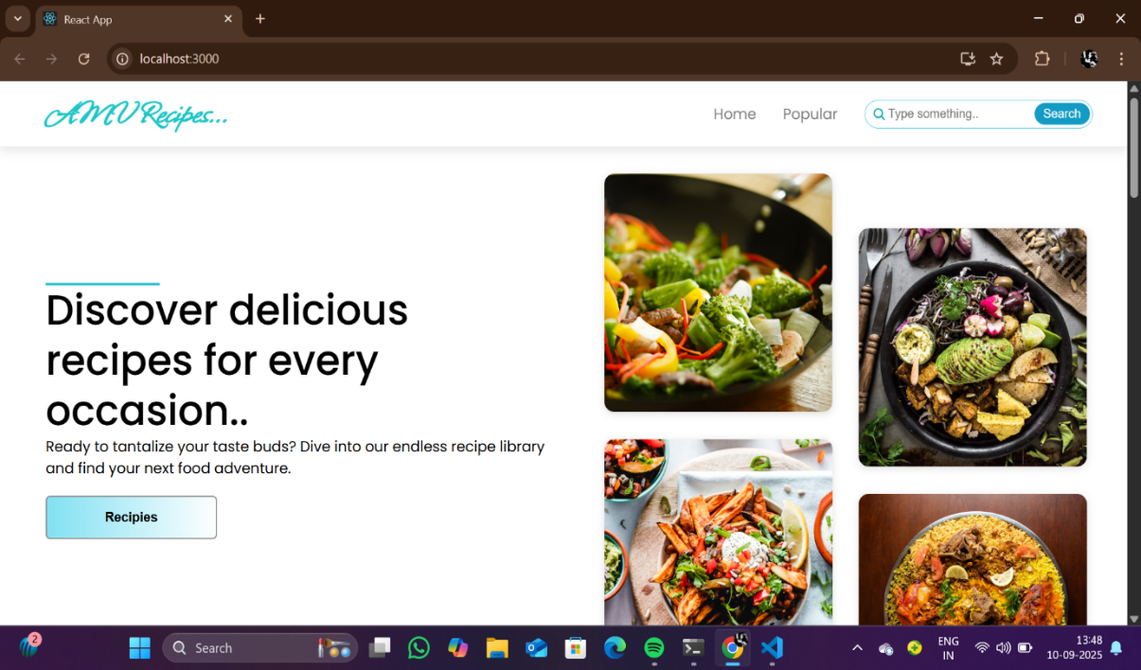

IMG 3: HOME PAGE OF THE APPLICATION

**COMPONENT DOCUMENTATION:**

**KEY COMPONENTS:**

* The home components serves as the landing page, showcasing featured a search bar and a call to action to explore the recipe library.
* The RECIPIES LIST COMPONENT displays all available recipes or filtered results based on user preferences.
* The POPULAR RECIPIES COMPONENT highlights trending or most -viewed recipes to help users find popular meals idea.
* The FAVORITES COMPONENT shows a list of recipes the user has saved or bookmarked.
* The USER PROFILE COMPONENT lets users manage their profile view saved recipes and update

preferences

**RESUABLE COMPONENTS:**

* The Recipe card component is used to display a summary of a recipe (image, title, time) across recipe listings.
* The Search bar component allows users to search for recipes by keyword and can be reused on the homepage or inside the header.
* The Header (or Navbar) component contains the app logo, navigation, links and sometimes the search input.
* The Footer component appears at the bottom of all pages and contains links to legal or informational pages.

**STATE MANAGEMENT:**

* **Global State:** Not implemented yet. Future plan -> Context API.
* **Local State:** Managed using useState within components.

**STYLING:**

* The application uses CSS modules for component-scoped styling, allowing styles to be locally scoped and avoiding global class conflicts.
* Utility-first styling eg: with Tailwind CSS can also be based on project preference.
* Global styles and theme variables (colors, fonts) are defined centrally for consistency.

**TESTING:**

* This application uses automated testing to ensure readability, maintainability, and correctness of core features.
* Testing is performed across components, pages, and utility functions using industry-standard tools.
* In future Jest and React Testing Library for unit testing.

**USER INTERFACE:**

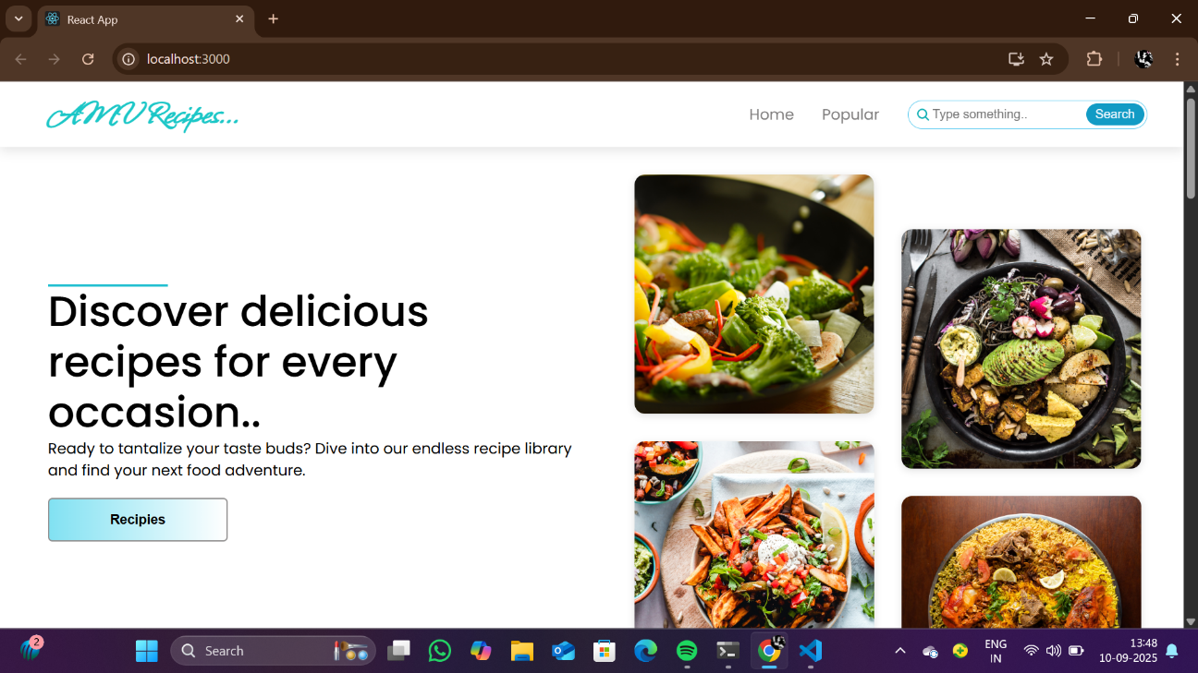

IMG 4: USER INTERFACE

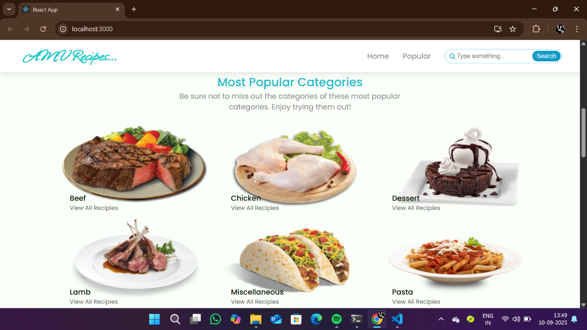

IMG 5: TRENDING DISHES

**KNOWN ISSUES:**

* No global state management yet.
* Limited routing.

**FUTURE ENHANCEMENTS:**

* Add authentication so users can create accounts and save their favorite recipes.
* Allows users to upload their own recipes with a form that include title, image, ingredients, and steps.
* Add a feature where users can click a button to save or bookmark recipes for easy access later.

**CONCLUSION:**

Cook Book is a helpful and easy-to-use mobile app designed to make cooking simpler and more fun for everyone, from beginners to experienced cooks.

Right now, the app has a strong foundation with its main features: a search bar to find recipes, a visually appealing home page with pictures of food, and a well-organized structure for browsing. It was built using modern and popular web technologies like React.js.